https://www.pes.edu/wp-content/uploads/2019/09/pes_logo.png

**B.TECH. (CSE)**

**V SEMESTER**

**UE20303 –SOFTWARE ENGINEERING**

**PROJECT REPORT**

**ON**

EMPLOYEE EFFICIENCY MANAGEMENT SYSTEM

**Team Members :**

|  |  |
| --- | --- |
| **Name** | **SRN** |
| Ghanashyam Mahesh Bhat | PES1UG20CS153 |
| Jeevan R | PES1UG20CS179 |
| Dhanvin S | PES1UG20CS125 |

|  |  |  |  |
| --- | --- | --- | --- |
| **Sl.No** | **TOPIC** | | **PAGE No** |
|  | PROPOSAL OF THE PROJECT | | 3 |
|  | SOFTWARE REQUIREMENTS SPECIFICATION | Introduction | 5 |
| Overall Description | 7 |
| Specific Requirement | 9 |
|  | PROJECT PLAN | | 10 |
|  | DESIGN DIAGRAMS | | 12 |
|  | TEST CASES | | 14 |
|  | SCREEN SHOTS OF OUTPUT | | 15 |

**Table of content :**

**PROPOSAL OF THE PROJECT**

Employees in IT companies often tend to take work less seriously and work without any consequences for their leisurely behavior. Some even push work until the deadline even though the work can be completed in less time. Many times, a hardworking and dedicated employee doesn’t get the deserved rewards and benefits because of a lack of efficient tracking and progress measures. During the time of recruitment the human resource team has to get in contact with the candidate’s previous employer to request his work profile, which is a difficult and repetitive task when it has to be done for every single candidate applying for the job.

The above all problems can be solved with the help of a tool which can track the employees’ efficiency in the workplace and thus help reward the employees based on their performance and help them improve in the required fields, thus building a quality work force.

To analyze and maintain the record of employee’s efficiency for easier profiling of the employee and measuring his growth rate, we will be calculating the efficiency of workers based on the activities and work they'll be doing at the workplace based on the number of breaks taken, checking browsing history, work completed, problem-solving ability, client management, communication, meeting the requirements, development quality, etc. The entire score of the employee is maintained using blockchain technology so that it can be displayed and can be considered by the next employer or internal team management, promotions, and work assignment.

The product will help in tracking the employee’s dedication towards work and maintaining all the previous reviews by the HR team. This will help to track the growth and development of the employee and reward him based on the same. Blockchain technology ensures the integrity of the data and it cannot be manipulated by anyone hence it can be used by the human resource team while recruiting a new employee and understanding his strengths and weaknesses as per the review of the previous employer. This immensely helps smart and dedicated employees to stand out among all the other employees and get better raises and promotions.

**SOFTWARE REQUIREMENTS SPECIFICATION**

**Introduction**

1. **Purpose:**

To analyze and maintain the record of employee’s efficiency for easier profiling of the employee and measuring his growth rate. Employees in IT companies often tend to take work less seriously and work without much consequences of their leisurely behavior. Some even push work until the deadline even though the work can be completed in less time . This can be avoided by maintaining a complete employment record which should be produced before joining a new workplace. By looking at the complete employment history and the scores of the candidate, the recruiter can get a rough estimate of the employee’s efficiency, his strengths and weaknesses as assessed by his previous employers.

1. **Scope:**

This tool can widely be used by the HR team of every company to assess and manage the employee details and their performance. This software manages the performance of the employee and the scope is as similar as the human resource.Since the fundamental aim of this software is to ensure good amount of work from every department in the organization/company.This particular system monitors everything people do at workplace from the vision/goals of the company to its employee and their personal interests,their intent, how well they have executed a particular task assigned to them against the company standards.It basically considers overall performance ,defines its goals,and helps to design a working strategy which can be implemented periodically and further can be used to analyze and inturn used to make better decisions for the growth of the company. And finally can be used to validate the employees selection process , identify their needs and rewards or benefits can be awarded accordingly.

**3**. **Definition, acronyms and abbreviations**

* HR - Human Resource
* IT - Information Technology
* BLE - Bluetooth Low Energy
* NLP - Natural Language Processing
* DBMS - Database Management Systems

**4. References :**

* Performance Management

https://www.shrm.org/hr-today/trends-and-forecasting/special-reports-andexpert-views/documents/performance-management.pdf

* Performance Management System: A Strategic Tool for Human Resource Management https://www.researchgate.net/publication/305720304_Performance_Mana gement_System_A_Strategic_Tool_for_Human_Resource_Management
* Performance Management

http://sjput.in/pdf/hrmiii_pm.pdf

**5. Overview :**

We will be calculating the efficiency of workers based on the activities and work they'll be doing at the workplace based on number of breaks taken , checking browsing history , work completed , problem solving ability , client management , communication , meeting the requirements , development quality etc. The entire score of the employee is maintained using blockchain technology so that it can be displayed and can be considered by the next employer or internal team management, promotions and work assignment.

**Overall Description**

**1. Product Perspective**

The product will help in tracking the employee’s dedication towards work and maintaining all the previous reviews by the HR team. This will help to track the growth and development of the employee and reward him based on the same. The blockchain technology ensures integrity of the data and it cannot be manipulated by anyone hence it can be used by the human resource team while recruiting a new employee and understand his strengths and weaknesses as per the review of the previous employer. This immensely helps the smart and dedicated employees to stand out among all the other employees and get better raises and promotions.

**2. Product Functions**

Some of the products features are :

* Indoor positioning system
  + - * 1. Constantly tracking position of the employee inside the office
        2. Using BLE Beacons for tracking
        3. Calculating effective working hours
* NLP based search history tracking -Analyzing browser search history to monitor Employee efficiency
* System active hour calculation -Calculating work timeline and active hour for efficiency mapping
* Normalizing score for different organization
* Maintains blockchain based performance history for every employee.
* This system gives automated prompts and reminders so the tasks will be completed on time.

**We Analyze the performance by the following metrics:**

* **Quantitative Metrics**: The simple way to measure since measuring quantity is easier than quality. We track the number of productive hours or time period for which he/she took a break from work or maybe the number of sales/ referrals .
* **Qualitative metrics:** This can be measured by feedback given by the HR or the manager and further weights can be assigned and get a score.
* **Efficiency metrics:** This basically considers both quantity and quality of the work.

1. **User Characteristics**

This will be very beneficial for companies who want to monitor or check how efficient their workers are doing . This will help the HR team during new recruitments as they get a brief idea about previous employment of the candidate from an authentic source. It helps the dedicated employees to stand out in their team and get a proper validation for their work.

1. **Constraints**

* One of the major constraints is for the companies to adopt this system since this can be a bit harsh on employees.
* Normalizing scores for different companies to give and store a generalized score.
* Taking manual scoring into consideration along with automated scoring.

1. **Assumptions And Dependencies**

Assumption is that the HR team is giving unbiased and accurate data about the employees or workers' various activities and performance. Assuming that the bluetooth broadcasting is allowed inside the workplace for BLE beacon based indoor positioning.

**Specific Requirements**

**External Interface**

Consists of User Interface requirements , Hardware and Software Interface requirements. User interface is where the user can interact with the software to update the score of each employee and find the final score and comparison between present and previous scores. Hardware interface includes bluetooth based indoor positioning system and software interface includes DBMS, browsing history tracking etc.

**Functional Requirements**

The functional requirements include the BLE beacons, esp32 based bluetooth based tracking, local database for data collection, server for efficiency calculation, and blockchain technology for maintaining a decentralized certificate.

**Non Functional Requirements**

Non functional requirements include, permission to analyze the browsing history, permission to track the movement of the employee inside the building and acceptance of the new scoring system.

**Design Constraints**

The limitation includes inability to automate every aspect of the efficiency matrix. Normalization of the score for each company may not be accurate.

**PROJECT PLAN**

**1. Lifecycle to be followed**

**The best suited lifecycle is component-based lifecycle.**

This is beacuse our tool can be divided into multiple components, i.e frontend, backend, local data maintainance, data acquiring module, data anlysis module, tracking module, blockchain data storage. Thus these components can be developed individually and be integrated in the end.

**2.Tools used**

|  |  |  |
| --- | --- | --- |
| **Planning Tool** | | **Jira** |
| **Design Tool** | | **Lucid Charts** |
| **Version Control** | | **Github** |
| **Development Tool** | | **VS code, Figma** |
| **Bug tracking** | | **Jira** |
| **Testing tool** | **Selenium** | |

**3.Resue/Build components**

All the components are Build components since these were not available open source.

**4.WBS of each task**

Blockchain – Dhanvin S

Frontend – Jeevan R

Backend and Tracking – Ghanashyam Bhat

**5.Estimate of the time required for each task**

Tracking – 1 Week

Backend – 3 Weeks

Database Design – 2 Weeks

Frontend – 8 Weeks

Blockchain – 8 Weeks

**6. Gantt Chart :**

**Work Breakdown Structure**

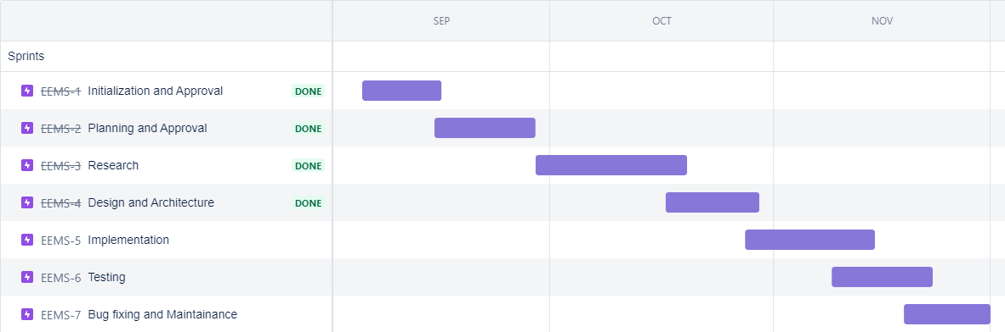

**DESIGN DIAGRAMS**

**System Architectural Designs**

**1. Low level Design**

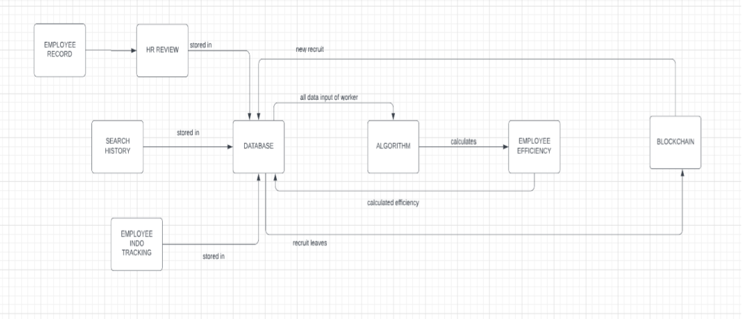

**2. High level Design**

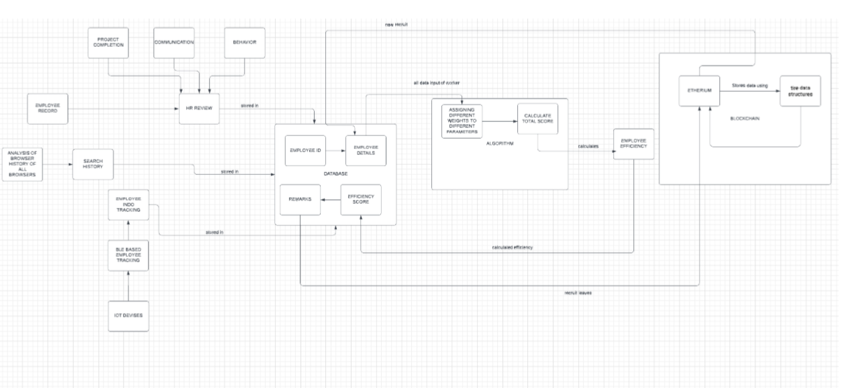

3. **Database Design**

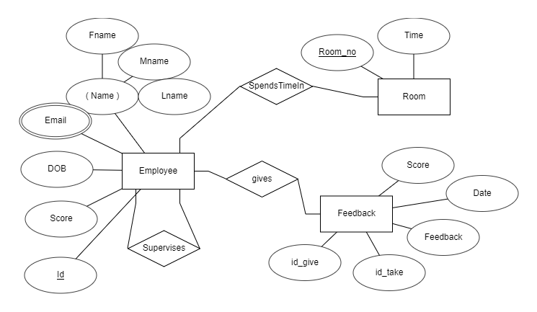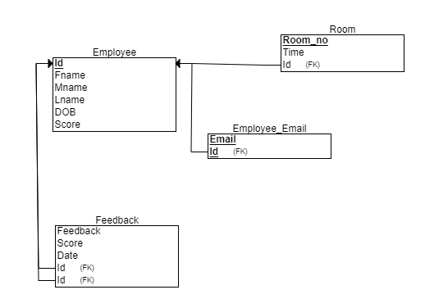

**TEST CASES**

|  |  |  |  |  |  |  |  |  |  |  |  |  |
| --- | --- | --- | --- | --- | --- | --- | --- | --- | --- | --- | --- | --- |
| Test Case ID | Name of Module | Test case description | | Pre-conditions | Test Steps | Test data | Expected Results | | | Actual Result | | Test Result |
| U-01 | Login module | To test the login page of the website | | Access to the browser and server running | 1. Navigate to the login window  2.Enter email ID and password  3. Press login button | Username: gigabyte@gmail.com  Password: password | Login should be successful with home age | | | Login successful with home page | | Pass |
| U02 | Login module | To test the login page of the website | | Access to the browser and server running | 1. Navigate to the login window  2.Enter email ID and password  3. Press login button | Username: gigabyte@gmail.com  Password: Password | Login failed should be displayed | | | Login failed window displayed | | Pass |
| U03 | Tracking module | | To test if the user’s current location is detected | Access to tracker and website | 1.Move around the building to record differnt value | NA | | Time spent in each room shoul d be recorded in database | Time spent is recorded but it was not accurate. | | Fail | |

**SCREEN SHOTS OF OUTPUT**

